Setting up an IK Spline

Note: You’ll be mainly working out of the outliner during this tutorial. As with most rigging there’s a point where you’ll no longer be able to select things via the viewport.

1. Name your joints accurately (ex: jt_hips > jt_lowerBack > jt_midBack > jt_upperBack etc)
2. Create a dummy joint chain that we’ll be using to control the clusters of our IK Spline (don’t worry, that’ll all make sense later). Select the parent joint of the hierarchy you’re splining (in my case that’s jt_hips) and duplicate it. Immediately rename that new hierarchy so you know they’re the dummy joints (I’m doing a spine, so I’m giving my new hierarchy the prefix “mbv” for ‘move back vert’ as that’s exactly what these dummy joints will be doing)

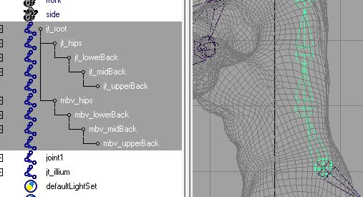

1. Creating the IKSpline
   1. Go to Animation > Skeleton > IK Spline Handle Tool > Options. Reset Tool and set the Number of Spans to 4.
   2. With the IK Spline Handle Tool active, in the Outliner select the parent joint of the hierarchy you’re splining (in my case that’s jt_hips) and hold down CTRL to select the last joint in the hierarchy you’re splining (in my case that’s jt_upperBack). This will automatically create an effector, ikhandle and curve in your Outliner.

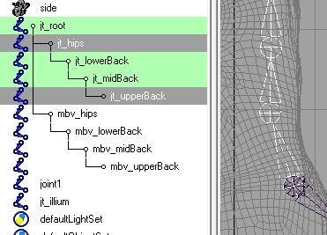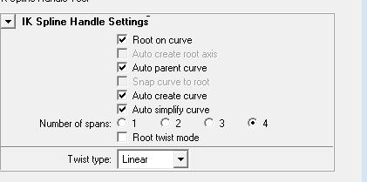

1. 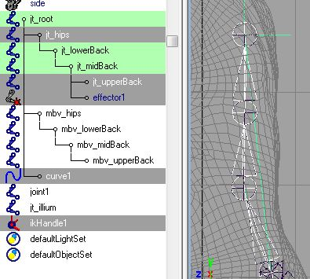Immediately rename the curve and ikHandle that have been created to something appropriate for this spline (ex: crv_spine and ikSpline_spine)
2. Next create clusters for your curve by selecting the curve then going to Surfaces > Edit Curves > Selection > Cluster Curve
3. 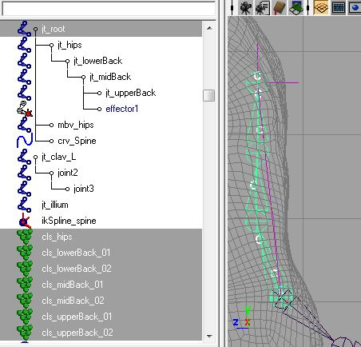Immediately rename your clusters after whichever joint is nearest to them (ex: if cluster1 is near jt_lowerBack then I’ll name it cls_lowerBack)
4. Parent these newly renamed clusters to the Main Root joint of your skeleton (select each of the clusters in the outliner and hold down CTRL to select the Main Root joint and hit “P”). They will automatically get grouped to themselves, just rename these groups for the clusters inside them (ex: the group for cls_lowerBack will be grp_cls_lowerBack).
5. Parent constrain the clusters (not the groups!!) to the appropriate dummy joints you created earlier (ex: I’ll be parent constraining cls_lowerBack_01 and cls_lowerBack_02 to mbv_lowerback – NOT THE ORIGINAL JOINT CHAIN! You are parent constraining the clusters to the dummy chain ONLY). Make sure Maintain Offset is on.
6. 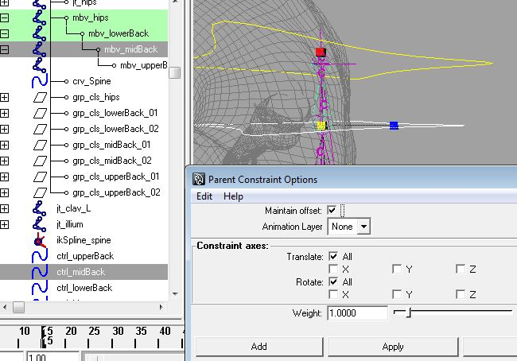Create controls for your spine. I’m creating a control for each individual mbv joint because my spine is pretty simple. If this were a particularly complicated rig with lots of joints as a part of my spline (like with a neck or tail) then I would create just a couple controls (top, middle and end for example) and have each of those control the mbv joints closest to them.
7. You MUST freeze transformations on your controls before you go any further.
8. Parent constrain your appropriate dummy joint to its nearest control (ex: parent constrain mbv_hips to ctrl_hips). Make sure Maintain Offset is on.
9. Last thing to do is set up your controls so that when you rotate the control at the base of your bending spline thing (the spine in my case) it will rotate everything above it, the next one up will only rotate stuff above IT, and the next one up will only rotate stuff about IT, etc. With the spine that means parent constraining each control to the control below it. For example, ctrl_upperBack is parent constrained to ctrl_midBack, ctrl_midback is parent constrained to ctrl_lowerBack, and ctrl_lowerBack is parent constrained to ctrl_hips
10. Rotate your controls to test out the bend of your spine. Your dummy chain will look like it’s breaking, but that’s okay, all that matters is that you have a smooth curved bend in your ORIGINAL skeletal joints.

